**SIDDAGANGA INSTITUTE OF TECHNOLOGY**

Tumkur-572103



**Speech Processing Lab Report**

Submitted to:

**Dr.Veena Karjigi**

**Associate Professor**

**Department of Electronics and Communication**

Submitted by:

**Ritabrata Sarkar 1SI19EC080**

**1.Generation of sinusoid**

**Code:**

import numpy as np

import matplotlib.pyplot as plt

#initial parameters

Fs=8000 #sampling rate

fm=1000 #frequency of sinusoid

tlen=1.0 #length in second

#generate time axis

tt=np.arange(np.round(tlen*Fs))/float(Fs)

#generate

sine xt=np.sin(2*np.pi*fm*tt)

#print the first 24 values of x(t)

plt.plot(tt[:40],xt[:40])

plt.grid() plt.show()

**Output:**

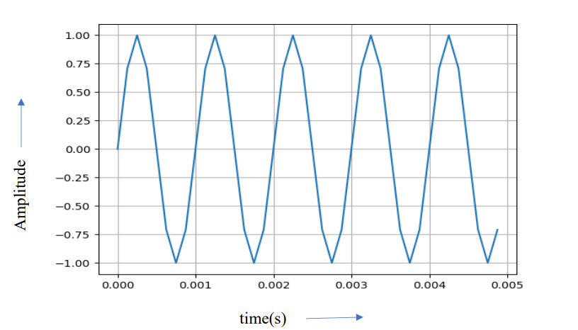

**2. DFT of a signal**

**Code:**

import numpy as np

import matplotlib.pyplot as plt

from array import *

x=array(‘1’,[1,2,3,4])

N=len(x) n=np.arange(N)

k=n.reshape((N,1))

e=np.exp(-2j*np.pi*k*n/N)

X=np.dot(e,x)

W=2*np.pi*n/N

print(n)

print(k)

print€

print(X)

plt.plot(W,np.abs(X))

plt.grid()

plt.show()

**Output:** 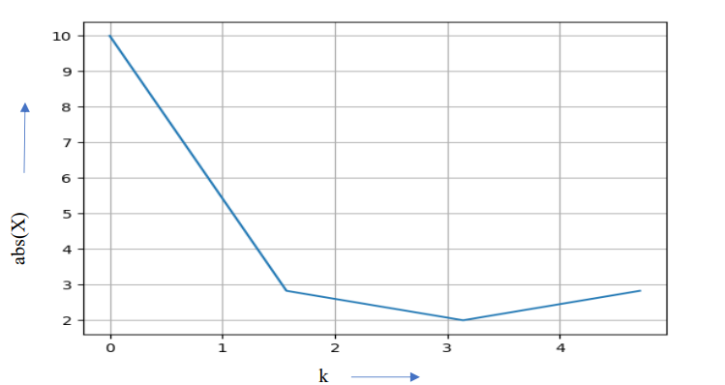

**3.Spectrum**

**Code:**

from scipy.io import wavfile

import scipy.io

import numpy as np

import math

from scipy.signal import hann

from scipy.fftpack import fft

import matplotlib.pyplot as plt

samplerate, data = wavfile.read(r'C:\Users\ritab\Desktop\speech_lab\fa.wav')

print(samplerate)

window = hann(40)

data_win=np.multiply(data[:40],window)

mags = abs(fft(data_win))

mags_dB=20*np.log10(mags)

N=len(data_win)

k=np.arange(N)

f=k*samplerate/N

plt.plot(f,mags_dB)

plt.ylabel("Magnitude (dB)")

plt.xlabel("Frequency in Hz")

plt.title("Spectrum")

plt.show()

**Output:**

Sample Rate=8KHZ

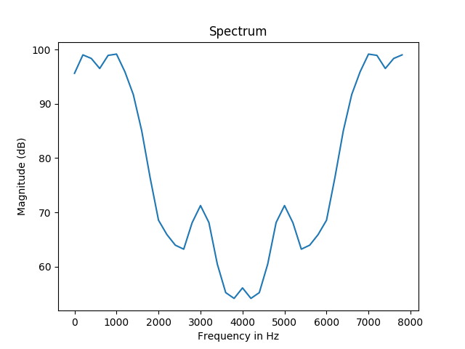

**4.Spectrogram**

**Code:**

from scipy.io import wavfile

import scipy.io

import numpy as np

import math

from scipy.fftpack import fft

from scipy.signal import hann

import matplotlib.pyplot as plt

samplerate, data = wavfile.read(r'C:\Users\ritab\Desktop\speech_lab\fa.wav')

print(len(data)/samplerate)

window=hann(240)

nvrlp=120

nframes=len(data)/nvrlp

nframes=int(nframes)

nframes=nframes-1

rows=nframes

frames=np.arange(nframes)

dft_frame=[[0]*512]*rows

time=[[0]*1]*rows

for i in frames:

frame_start=i*nvrlp

data_select=data[frame_start:frame_start+240]

data_win=np.multiply(data_select,window)

dft_frame[i]=20*np.log10(np.abs(fft(data_win,512)))

time[i]=i*(120/8000)

print(np.shape(dft_frame))

dft_frame_t=np.transpose(dft_frame)

plt.imshow(dft_frame_t[257:512])

plt.show()

**Output:**

print(len(data)/samplerate)=0.441

print(np.shape(dft_frame))= (28, 512)

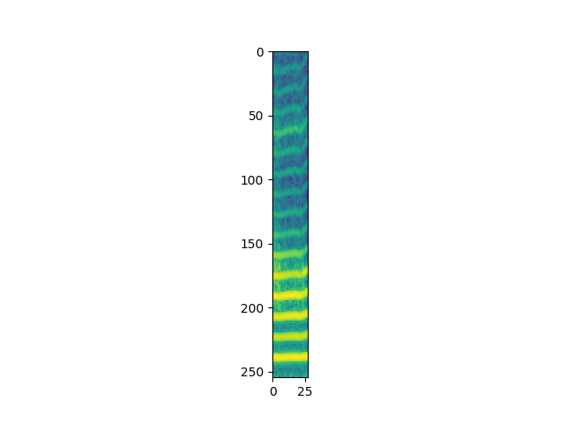

**5.Energy and ZCR:**

**Code:**

from scipy.io import wavfile

import scipy.io

import numpy as np

import math

from scipy.signal import hann

import matplotlib.pyplot as plt

samplerate, data =wavfile.read(r'C:\Users\ritab\Desktop\speech_lab\fa.wav')

print(len(data)/samplerate)

window=hann(240)

nvrlp=120

nframes=len(data)/nvrlp

nframes=int(nframes)

nframes=nframes-1

cols=240

rows=nframes

frames=np.arange(nframes)

samples=np.arange(cols)

Energy=[[0]*1]*rows

ZCR=[[0]*1]*rows

time=[[0]*1]*rows

for i in frames:

frame_start=i*nvrlp

data_select=data[frame_start:frame_start+240]

data_win=np.multiply(data_select,window)

Energy[i]=sum(pow(data_win,2))

for j in samples:

ZCR[i]=ZCR[i]+abs(np.sign(data_win[j])-np.sign(data_win[j-1]))

time[i]=i*(120/8000)

signal_samples=np.arange(len(data))/samplerate

plt.subplot(311)

plt.plot(signal_samples,data)

plt.subplot(312)

plt.plot(time,Energy)

plt.subplot(313)

plt.plot(time,ZCR)

plt.show()

**Output:**

print(len(data)/samplerate)=0.441

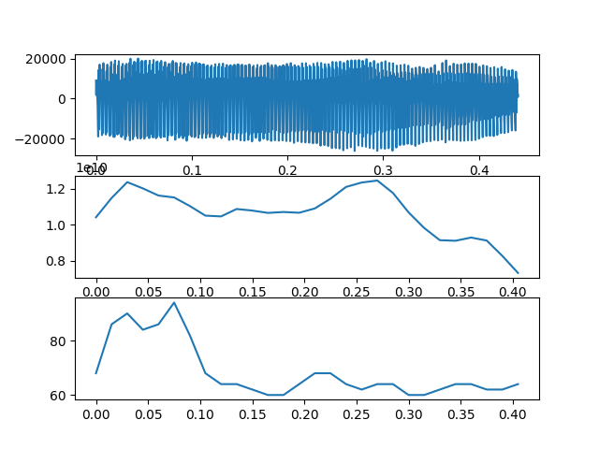

**6.Linear Predictive Co-efficients:**

**Code:**

from scipy.io import wavfile

import scipy.io

import numpy as np

import math

from scipy.fftpack import fft

from scipy.signal import hann

import matplotlib.pyplot as plt

from scipy.linalg import solve_toeplitz, toeplitz

samplerate, data = wavfile.read(r'C:\Users\ritab\Desktop\speech_lab\fa.wav')

frame=data[:480]/32768

lp_order=10;

len_sig=len(frame)

auto_corr=np.correlate(frame,frame,"full")

st=len_sig-1

en=2*len_sig-1

norm_auto=auto_corr[st:en]/auto_corr[st]

b=np.array((norm_auto[1:lp_order+1]))

c=norm_auto[:lp_order];

r=c;

lpcoeffs=solve_toeplitz((c,r),b)

print(lpcoeffs)

**Outputs:**

[ 2.14681112 ,-1.89570141,0.53654544, -0.09261142, 0.76286507,

-0.86370883, 0.11689183, 0.35352519, -0.19824816 ,-0.01905677]

**7.Cepstrum of given signal**

**Code:**

from scipy.io import wavfile

import scipy.io

import numpy as np

import math

from scipy.signal import hann

from scipy.fftpack import fft

from scipy.fftpack import ifft

import matplotlib.pyplot as plt

samplerate, data = wavfile.read(r'C:\Users\ritab\Desktop\speech_lab\fa.wav')

print(samplerate)

mags = np.abs(fft(data[:480],1024))

log_mags=np.log(mags)

ceps=ifft(log_mags)

t=(np.arange(480))/samplerate

#print(np.abs(ceps[:480])

plt.plot(t,np.abs(ceps[:480]))

plt.show()

**Output:**

